
IT AND BUSINESS COLLEGE
Department: Computer Science
Project title: Automated watering system
Team name: Team-3

Members:
Emir Azizmuratov
Chingiz Tugolbaev
Chyngyz Bayishbekov
Eldiyar Naamatov
Suiunbek Zhumakmatov
Group: CSC-24
Date:

Abstract

Our project is an automated plant watering system based on Arduino. We use a moisture sensor to automate the watering process, and we aim to develop a user-friendly app that allows for custom watering settings.

1.1Pump connection diagram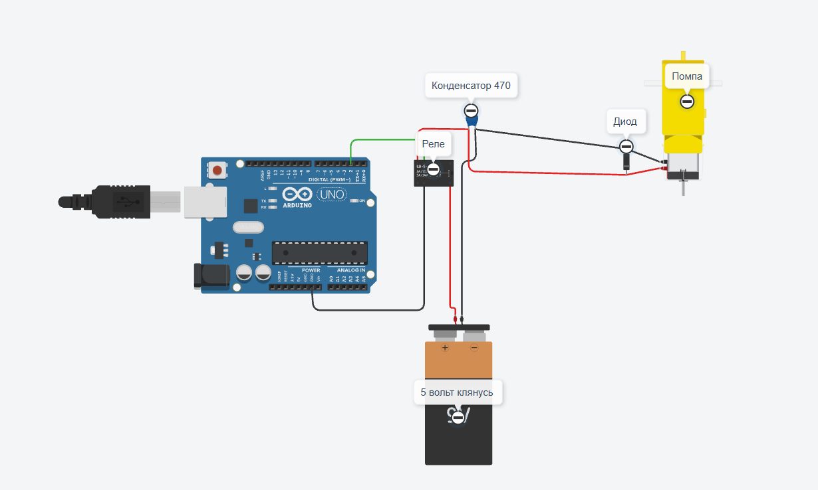

1.2 Soil moisture sensor wiring diagram
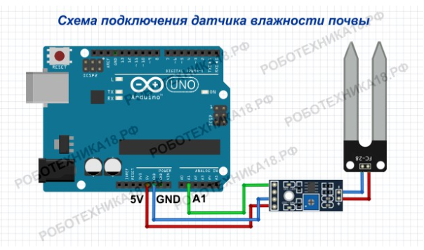
1.3 Bluetooth module wiring diagram
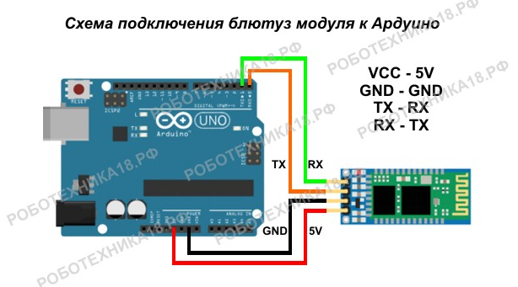

The circuit is from the internet because it can't be built in Tinkercad.

Component | Purpose | Image  Reference
Arduino Uno R3 | Central microcontroller and processing unit | Figure 1
Soil moisture sensor | Measures volumetric water content by electrical resistance or capacitance. Provides a voltage to A0 proportional to moisture. | Figure 2
HC-05 Bluetooth module | Wireless communication for mobile app | Figure 3
Single relay channel module | Acts as an electronic switch. Arduino digital output drives its input; the relay common/NO terminals switch the pump’s supply. | Figure 4
Water pump (5V submersible) | Delivers water when powered. Requires ~200 mA. Placed in a reservoir or bucket, connected via a plastic hose to the plant. | Figure 5
Power supply (power bank) | Provides stable power for the motor and electronics | Figure 6
Table 1. Components we used

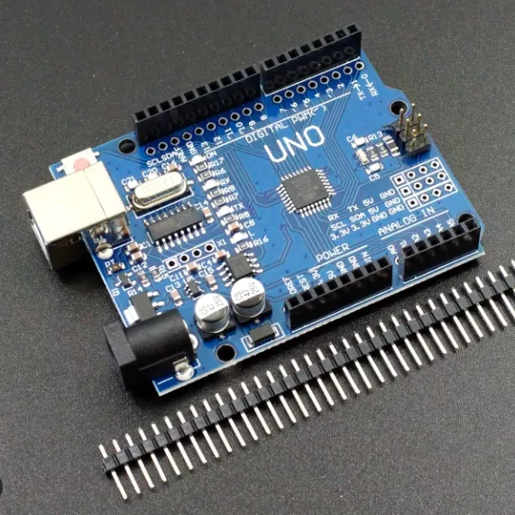
Figure 1. Arduino UNO R3 Microcontroller

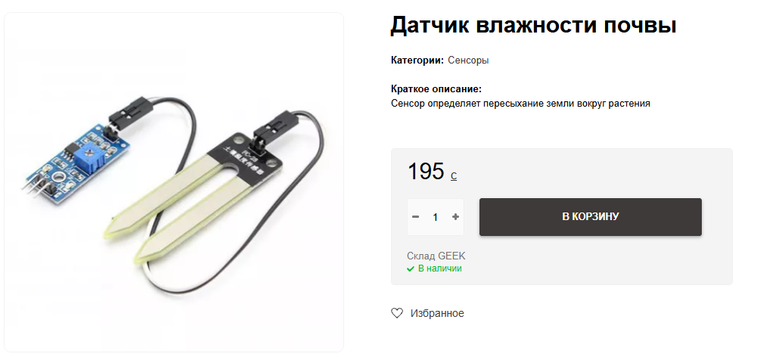

https://geek.kg/fc-28/
Figure 2. Soil moisture sensor
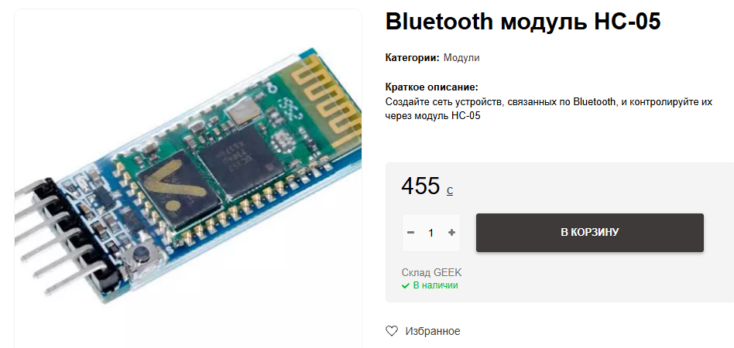

https://geek.kg/bluetooth-modulya-hc-05-bc417/
Figure 3. HC-05 Bluetooth Communication Module

We Have

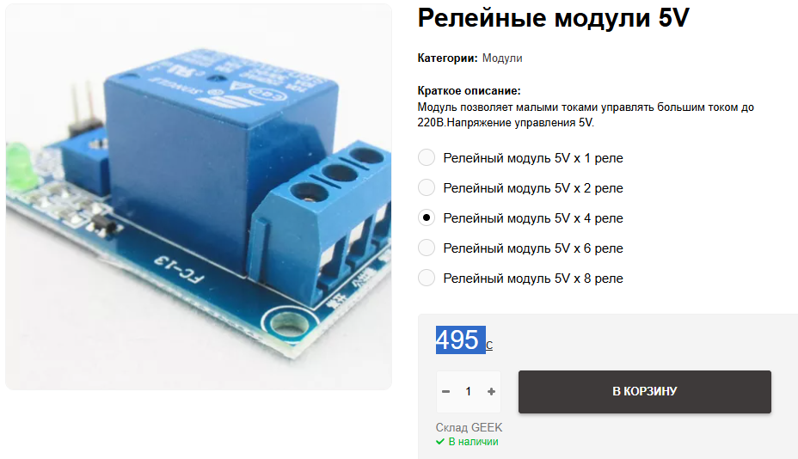
We Have
Figure 4. Single relay channel module

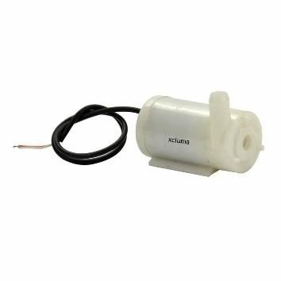

Figure 5. Water pump (5V submersible)
We have
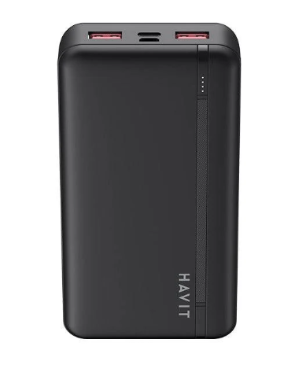

Figure 6. Power supply

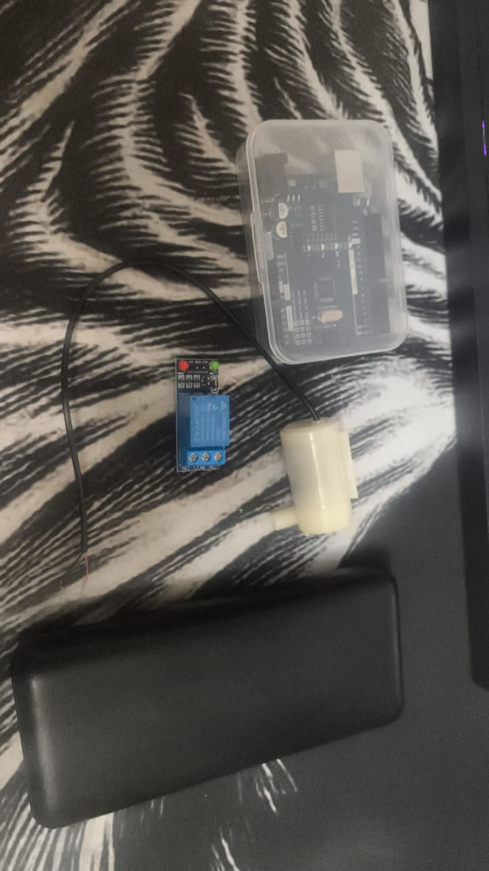

We didn’t want to inflate the budget; we’d like to keep the total under 1000 som. We plan to buy everything at the Geek store, located at 240 Chuy Avenue.

